Installing and Configuring Oracle Client Software

Because system configurations and individual company standards vary, use this section as a checklist instead of as step-by-step instructions. Please contact Customer Support for specific configuration questions.



* Smart 3D is a 32-bit application that uses the 32-bit Oracle Client even when loaded on a 64-bit client operating system.
* However, the 64-bit Oracle Client is required on computers where the 64-bit Interference Checker or 64-bit Drawings Batch Publishing is installed.
* Do not use the Oracle "light client" as it does not include some DLLs required by Smart 3D.
* You do not need to install the Oracle Client if you are using Microsoft SQL Server as your database provider.
* The Oracle Client and the **tnsnames.ora** file must be installed and configured on computers running batch services, interference checking, or the name generator service.
* You must configure the**tnsnames.ora** file for both 32-bit and 64-bit Oracle Client if both Oracle 32-bit and Oracle 64-bit are installed on a computer.

Oracle 12c Client Installation

This section guides you through installing Oracle 12c client software. Oracle 64-bit client is required on computers running 64-bit interference checking, 64-bit drawings batch publishing, and Intergraph Smart 3D Web API.

1. Double-click the Oracle **Setup.exe**.
2. Select **Custom** installation, and then click **Next**.

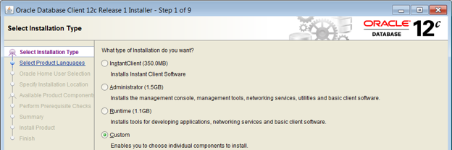

1. Select **English**, and then click **Next**.
2. On the **Oracle Home User Selection** page, select **Use Windows Built-in Account**. Click **Next**.

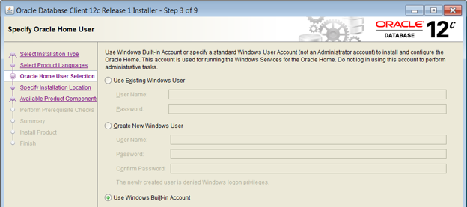

1. In the **Oracle Base** box, enter a unique folder location for the Oracle client.
2. In the **Software Location** box, enter a unique folder location.
3. Click **Next**.
4. On the **Available Product Components** page, select the options as shown below. Clear the **Oracle SQL Developer** option.

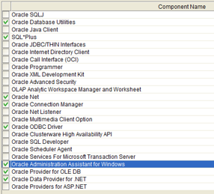

1. Click **Next**.
2. Click **Next**.

*Oracle performs prerequisite checks.*

1. Click **Install**.
2. Click **Cancel** on the **Oracle Net Configuration Assistant** window.

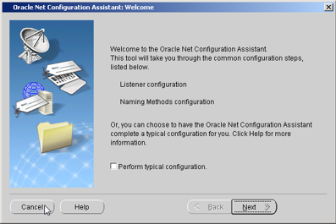

1. Click **Yes** to confirm that you want to cancel.
2. Click **OK** on the **Oracle Net Configuration Assistant failed** error message.
3. Click **Next** to exit the Oracle client installation.

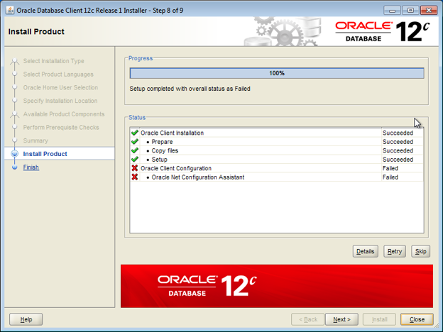

1. Click **Yes** on the message that the installation was successful but the configuration assistant failed.
2. Click **Close**.
3. Copy the TNSNAMES.ORA file from another previously configured system. The TNSNAMES.ORA file is located in <Oracle Home>\Network\Admin.
4. Run these two commands from a "Run as administrator" command prompt. Replace <ORACLE_HOME> with the Oracle installation folder, usually C:\app\<oracle_user>. If the 32-bit and 64-bit versions of Oracle 12.2 are both installed on the server, then these commands must be run for each install.

**32-bit Install**

SET ORACLE_HOME=<ORACLE HOME>\product\12.2.0\x86

<ORACLE_HOME>\product\12.2.0\x86\odp.net\bin\4\OraProvCfg.exe /action:gac /providerpath:<ORACLE_HOME>\product\12.2.0\x86\odp.net\bin\4\Oracle.DataAccess.dll

**64-bit Install**

SET ORACLE_HOME=<ORACLE HOME>\product\12.2.0\x64

<ORACLE_HOME>\product\12.2.0\x64\odp.net\bin\4\OraProvCfg.exe /action:gac /providerpath:<ORACLE_HOME>\product\12.2.0\x64\odp.net\bin\4\Oracle.DataAccess.dll



* + The same command line commands must also be run on the Name Generator computer.
  + Run the commands again on any computer after installing Oracle patch 28810696.
  + Global Workshare does not work with Oracle July 2018 Interim Patch# 27937914 or Oracle October 2018 Interim Patch# 28574555 bundle patches on Oracle 12.2.0.1.

Configure the Oracle Client

Oracle client computers must be configured before they can connect to an Oracle database.

1. Start Oracle **Net Manager**.
2. Select the Service Naming node, and then click the green plus sign to start the **Net Service Name Wizard**.

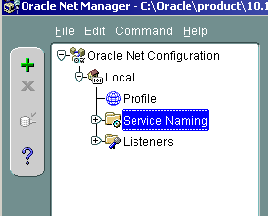

1. Specify a **Service Name**.

 The **Service Name** must be the same on the server and client. You will need to provide this net service name when creating databases, bulkloading and configuring Workshare.

1. Select **TCP/IP (Internet Protocol)**.
2. Specify the **Host name** (typically the network name of the database server computer) and **Port Number** (default=1521) for your protocol settings.
3. Specify the **Service Name** and **Connection Type**.
4. Test the new service.
5. If the default test fails, click **Change Login**, type a valid username/password combination and, retest the connection.
6. When the login test is successful, click **Finish** to close the wizard.
7. Click **File > Save Network Configuration** to save your new network service.

See Also

[Installing and Configuring Oracle Client Software](https://docs.hexagonppm.com/reader/XNI2thZWwpu_8XwBCfLFPQ/uaz8QMNaz~BE6NeLHDSKjQ)

Configure Windows Firewall for the Oracle Client

The Windows Firewall state is **On**by default to block incoming connections on most TCP network ports. As a result, an Oracle client reports errors when it requires an incoming connection from an Oracle server. You must adjust the Windows Firewall settings after installing Oracle client software to allow exceptions for the needed incoming connections.

 If the Windows Firewall state is **Off**on the Oracle client, then you do not need to change the configuration.

Open the Windows Firewall Control Panel

1. Open **Windows Firewall**.

*The****Windows Firewall****control panel appears.*

1. In **Public networks**, verify that the**Windows Firewall state** is **On**.
2. In **Control Panel Home**, click**Advanced settings**.

*The****Windows Firewall with Advanced Security****management console appears.*

Add an Exception for the Oracle Listener Port

1. In the left panel of the **Windows Firewall with Advanced Security** management console, click **Inbound Rules**.
2. In the **Action**panel on the right, click**New Rule**.

*The****New Inbound Rule Wizard****appears.*

1. On the **Rule Type** page, select **Port**and then click **Next**.
2. On the **Protocol and Ports** page, select **TCP**.
3. Select **Specific local ports**, and then type **1521**. Click **Next**.

 The default Oracle listener port is 1521. Your network configuration might require a different port number.

1. On the **Action**page, select **Allow the connection** and then click **Next**.
2. On the **Profile**page, select the needed options for **Domain**, **Private**, and **Public**, as required by your network configuration and allowed by the security policy of your company. Click **Next**.
3. On the **Name**page, type **Oracle Listener Port** as the name for the port exception. Optionally, you can type a description.
4. Click **Finish**.
5. In the center of the **Inbound Rules** panel, verify that the new exception name appears.